**Name : Sharma Anish Ashok**

**Roll No : 11**

**SAP ID : 60003220045**

**Branch : Information Technology**

**Div : D**

**Batch : IT1**

**Experiment No. 11:**

Write C program to find GCD of two integers by using recursive function. Write algorithm and draw flowchart for the same.

**Aim :** To find GCD of two integers by using recursive function

**Algorithm :**

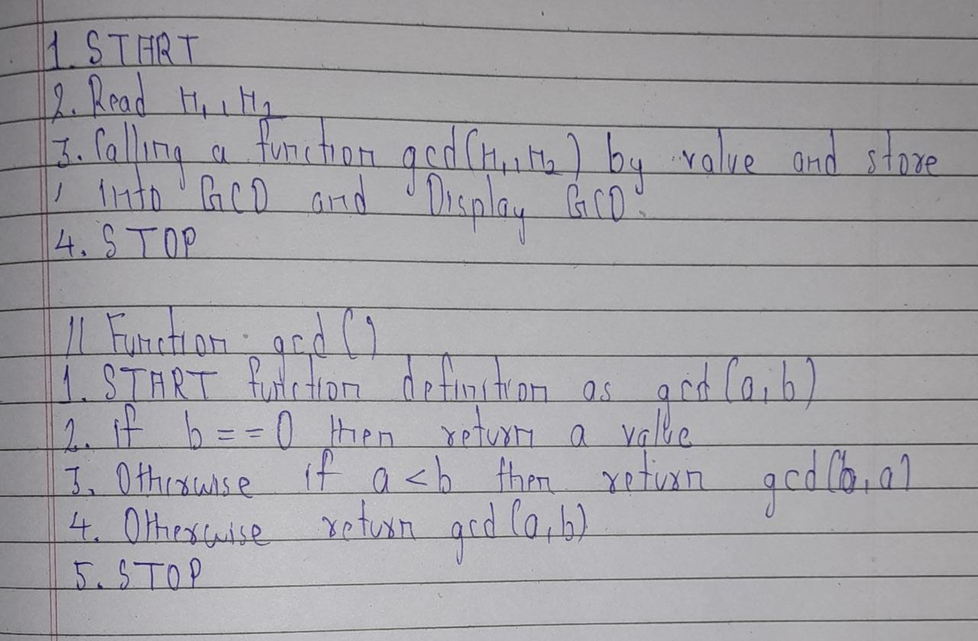

**Flowchart :**

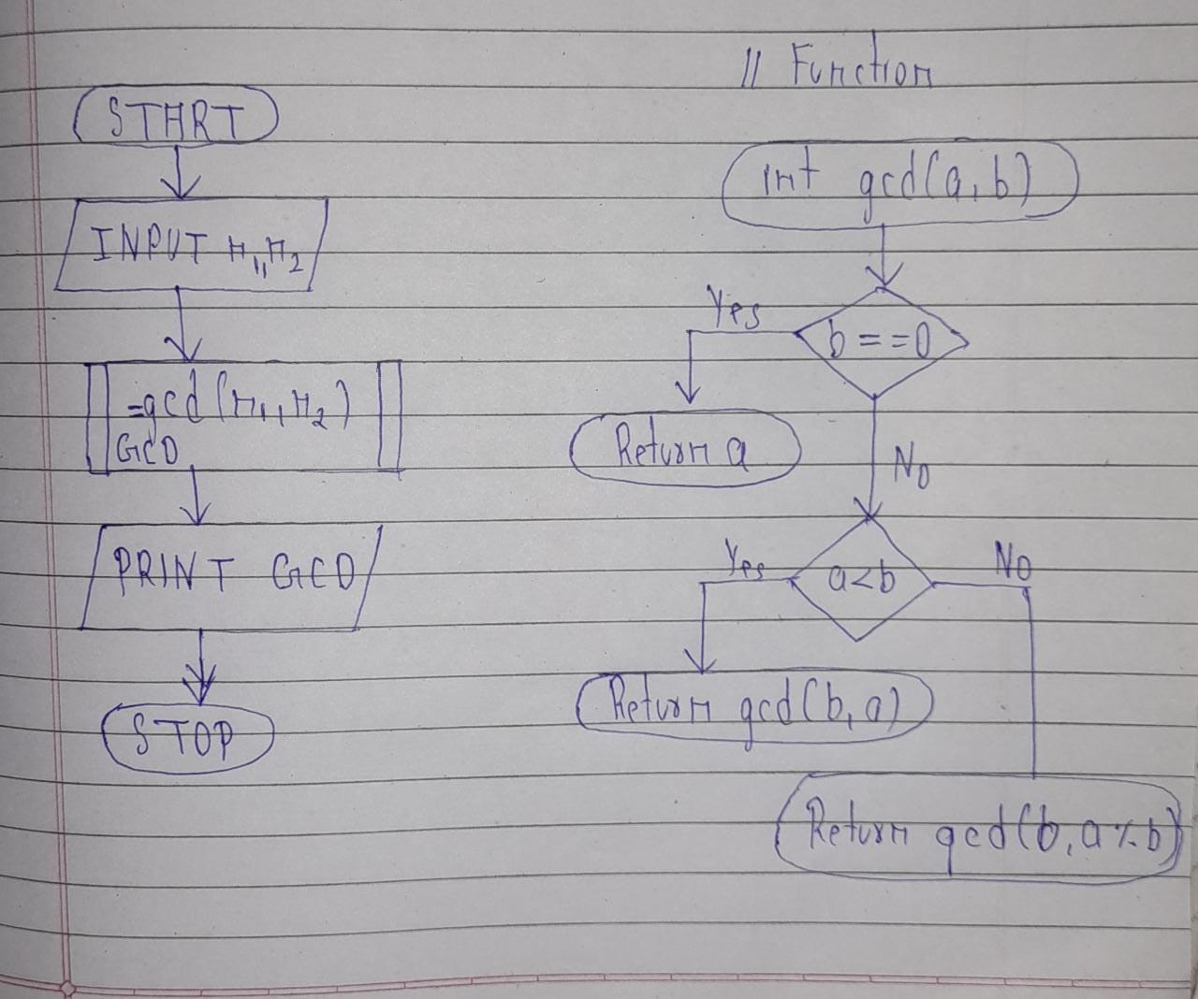

**Code :**

#include<stdio.h>

#include<conio.h>

int gcd(int a,int b)

{

if(b==0)

return a;

else{

if(a<b)

return gcd(b,a);

else

return gcd(b,a%b);

}

}

void main()

{

int n1,n2,GCD;

//clrscr();

printf("Enter your two number :\n");

scanf("%d %d",&n1,&n2);

GCD=gcd(n1,n2);

printf("GCD of %d and %d is %d",n1,n2,GCD);

getch();

}

**Output:**

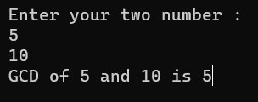

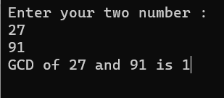

**Conclusion :**

We learn the recursive function through this example .And also the importance of recursive function in a program of GCD.

**Experiment 12 :**

Write a C program to find both the largest and smallest number in a list of integers. Write algorithm and draw flowchart for the same.

**Aim :**

To find largest and smallest number in a list of integers.

**Algorithm :**

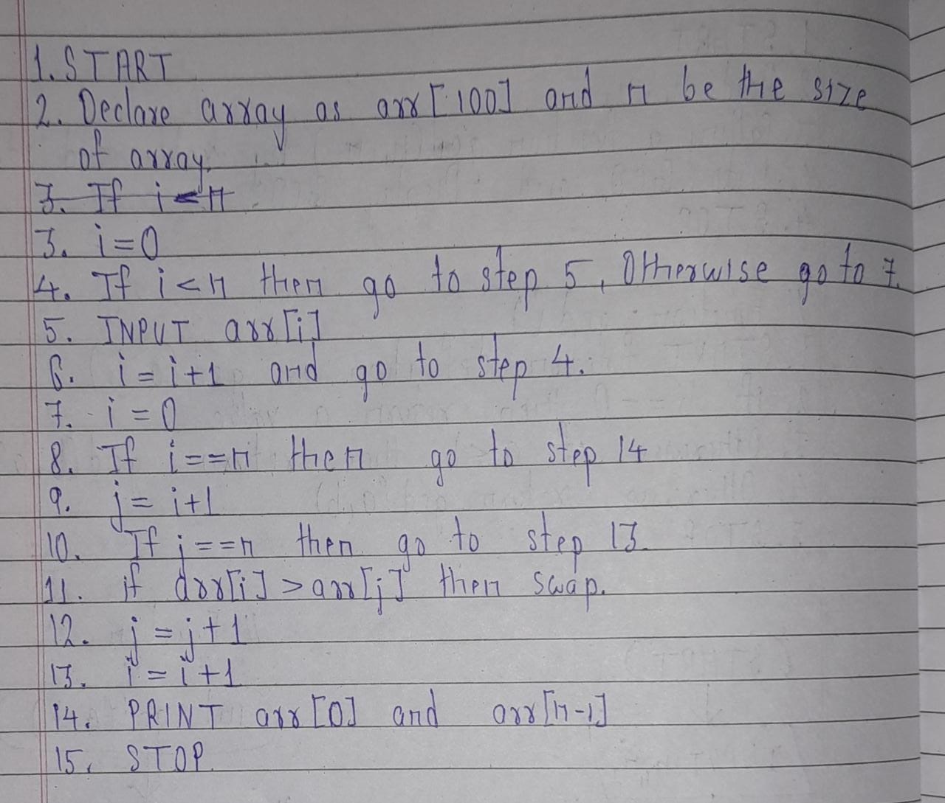

**Flowchart :**

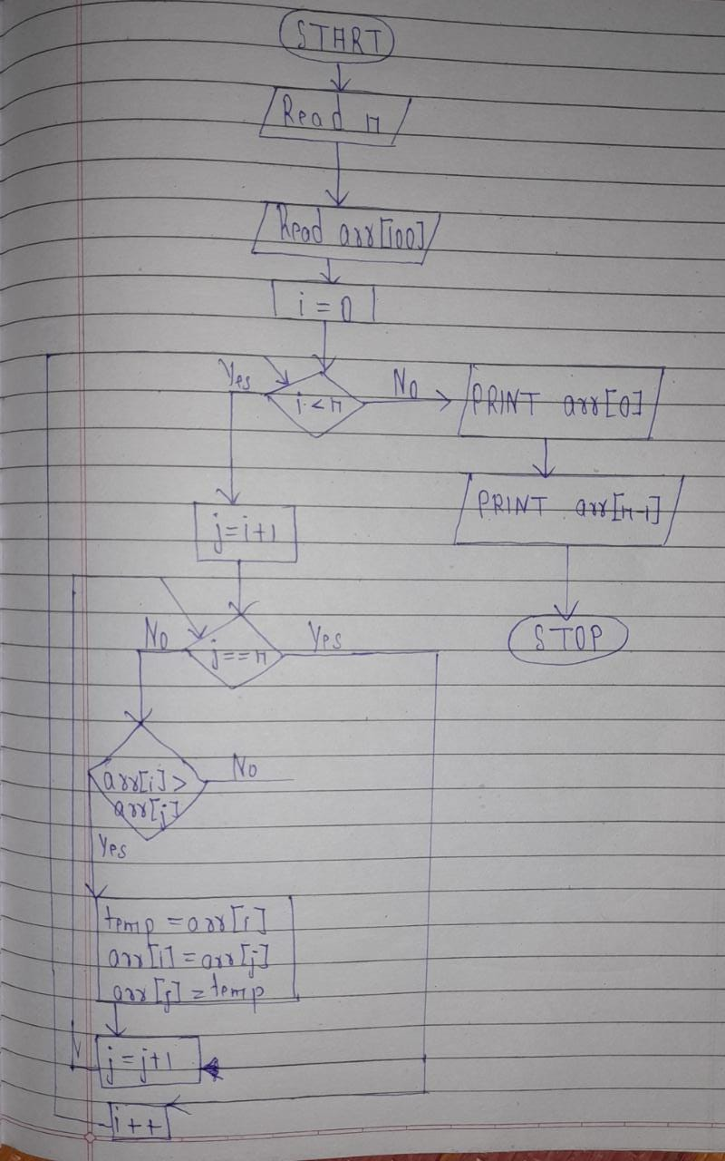

**Code :**

#include<stdio.h>

#include<conio.h>

void main()

{

int i,j,arr[90],n,temp=0;

//clrscr();

printf("Enter array size:\n");

scanf("%d",&n);

printf("Enter array element:\n");

for(i=0;i<n;i++)

{

scanf("%d",&arr[i]);

}

printf("\nPrinting array:\n");

for(i=0;i<n;i++)

{

printf("%d ",arr[i]);

}

for(i=0;i<n;i++)

{

for(j=i+1;j<n;j++)

{

if(arr[i]>arr[j]){

temp=arr[i];

arr[i]=arr[j];

arr[j]=temp;

}

}

}

printf("\nSmallest element from list is :%d",arr[0]);

printf("\nLargest element from list is %d",arr[n-1]);

getch();

}

**Output :**

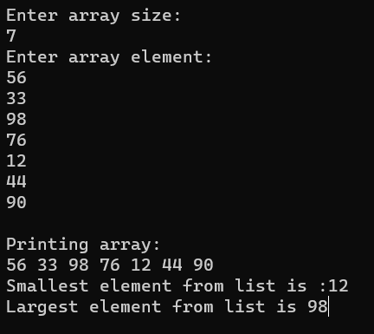

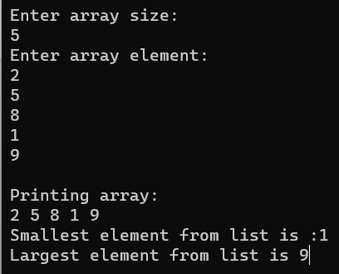

**Conclusion :**

Due to this program we aware of array and it’s important in day to day life. Array is a collection of element of same data type .

**Experiment 13 :**

Develop, implement and execute a C program that reads two matrices A (m x n) and B (p x q) and Compute product of matrices A and B. Read matrix A and matrix B in row major order and in column major order respectively. Print both the input matrices and resultant matrix with suitable headings and output should be in matrix format only.

**Aim :**

Study of matrix and 2D array.

**Code :**

#include<stdio.h>

#include<conio.h>

void input_print_matrix(int matrix[10][10],int row,int col)

{

int i,j;

printf("\nEnter matrix element :\n");

for(i=0;i<row;i++)

{

for(j=0;j<col;j++)

{

scanf("%d",&matrix[i][j]);

}

}

printf("\nPrinting matrix :\n");

for(i=0;i<row;i++)

{

for(j=0;j<col;j++)

{

printf("%d ",matrix[i][j]);

}

printf("\n");

}

}

void main()

{

int i,j,k,row1,col1,row2,col2,sum,m1[10][10],m2[10][10],m3[10][10];

//clrscr();

printf("\nEnter row and column of matrix 1:\n");

scanf("%d %d",&row1,&col1);

printf("\nEnter row and column of matrix 2:\n");

scanf("%d %d",&row2,&col2);

if(col1==row2)

{

input_print_matrix(m1,row1,col1);

//print_matrix(m1,row1,col1);

input_print_matrix(m2,row2,col2);

//print_matrix(m2,row2,col2);

printf("\nMultiplication of two matrix is:\n");

for(i=0;i<row1;i++)

{

for(j=0;j<col2;j++)

{

sum=0;

for(k=0;k<row1;k++)

{

sum=sum+m1[i][k]+m2[k][j];

}

m3[i][j]=sum;

}

}

for(i=0;i<row1;i++)

{

for(j=0;j<col2;j++)

{

printf("%d ",m3[i][j]);

}

printf("\n");

}

}

else

printf("\nMultiplication not possible ...");

getch();

}

**Output :**

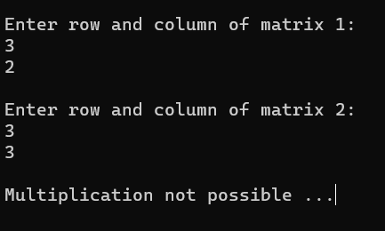

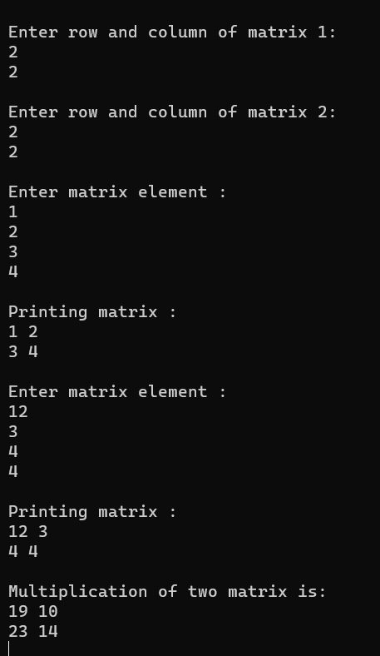

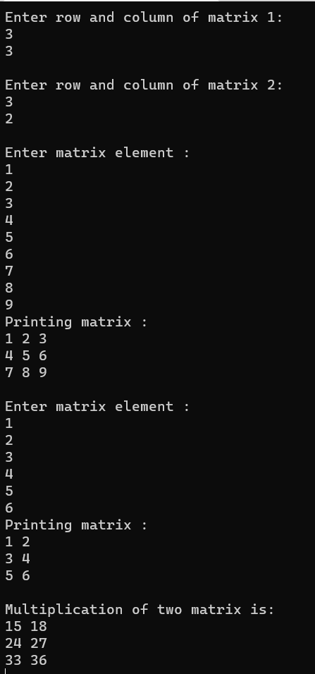

**Conclusion :**

Through this program we learn multiplication of matrix along with 2D array .

**Experiment No. 14**

Write a Program for deletion of an element from the specified location from Array.

**Aim :**

Deletion of an element from array

**Code :**

#include<stdio.h>

#include<conio.h>

void main()

{

int i,j=0,n,pos,arr[100];

//clrscr();

printf("Enter your array size:\n");

scanf("%d",&n);

printf("\nEnter your element is array:\n");

for(i=0;i<n;i++)

{

scanf("%d",&arr[i]);

}

for(i=0;i<n;i++)

{

printf("%d ",arr[i]);

}

printf("\nEnter your position to want to delete that element from array:\n");

scanf("%d",&pos);

if(pos>=n)

printf("Out of range !\nEnter valid position of element");

else

{

printf("\nYour element is deleted :%d",arr[pos]);

for(i=0;i<n;i++)

{

if(arr[pos]!=arr[i])

{

arr[j]=arr[i];

j++;

}

}

printf("\nPrinting Array after deletion process:\n");

for(i=0;i<n-1;i++)

{

printf("%d ",arr[i]);

}

}

getch();

}

**Output :**

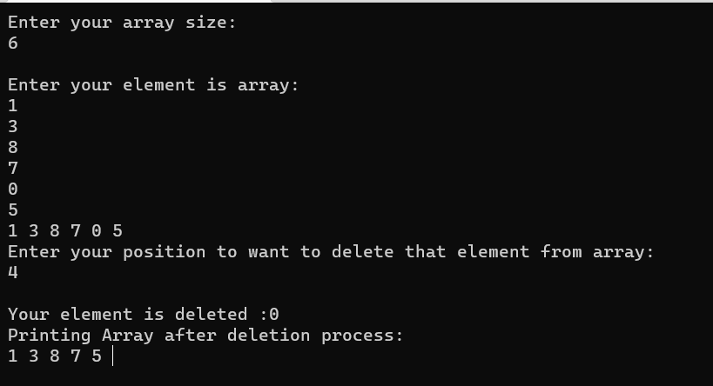

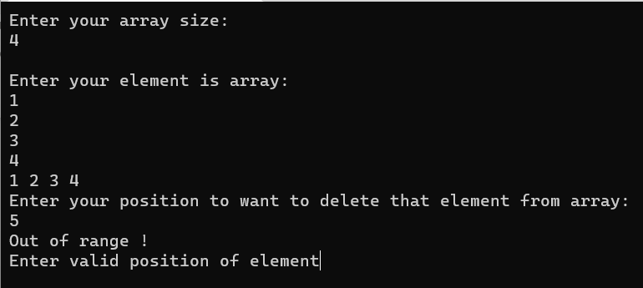

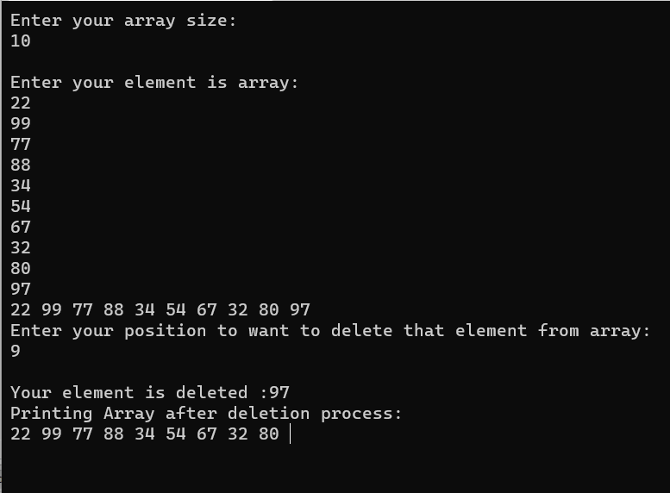

**Conclusion :**We studied and practice complex array through this program. How to delete an element from array .

**Experiment 15 :**

Write a C program using user defined functions to determine whether the given string is palindrome or not.

**Aim :**

Study of palindrome using user defined function.

**Code :**

#include<stdio.h>

#include<conio.h>

void main()

{

int n,rem,store,rev=0;

//clrscr();

printf("Enter your number :\n");

scanf("%d",&n);

store=n;

while(n>0){

rem=n%10;

rev=rev*10+rem;

n/=10;

}

if(store==rev)

printf("\nThe given number is palindrome");

else

printf("\nThe given number is not palindrome");

}

**Output :**

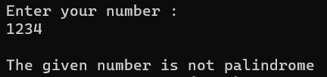

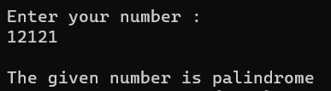

**Conclusion :**

We learn how to check whether a number is palindrome or not by using loop concept .